Kubernetes – 10 EKS
Prerequisites:

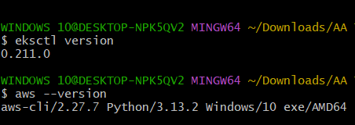

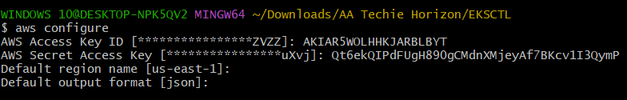

1) Setup EKS cluster using eksctl

YAMLs

eks-free-tier.yaml
---
apiVersion: eksctl.io/v1alpha5
kind: ClusterConfig
metadata:
name: free-tier-eks
region: us-east-1
version: "1.28"
vpc:
clusterEndpoints:
publicAccess: true
privateAccess: false
publicAccessCidrs:
- 0.0.0.0/0
nodeGroups:
- name: free-tier-nodes
instanceType: t3.small
desiredCapacity: 2
minSize: 2
maxSize: 3
volumeSize: 20
iam:
withAddonPolicies:
autoScaler: true
ebs: true
albIngress: true
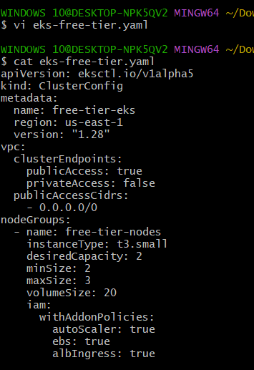

Commands
eksctl create cluster -f eks-free-tier.yaml # Create EKS cluster using the provided YAML

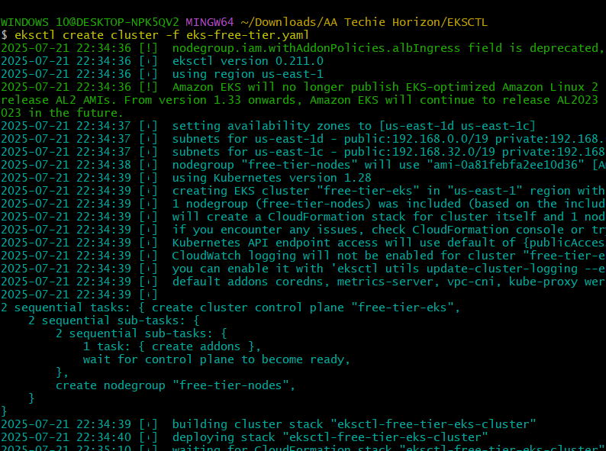
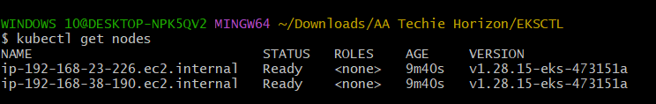
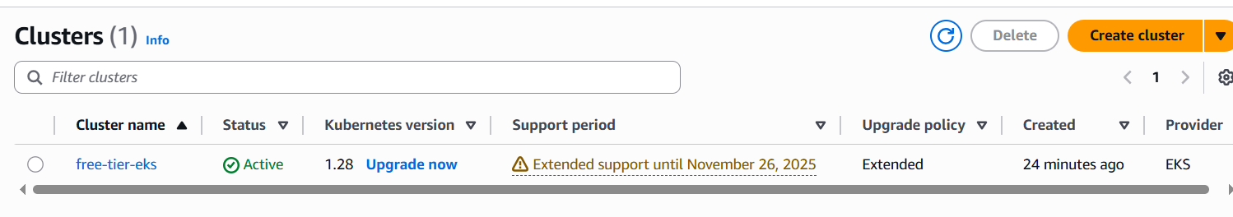
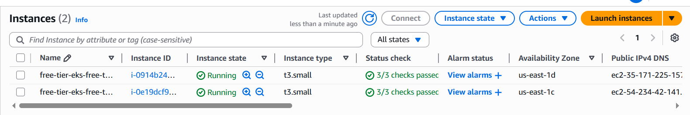
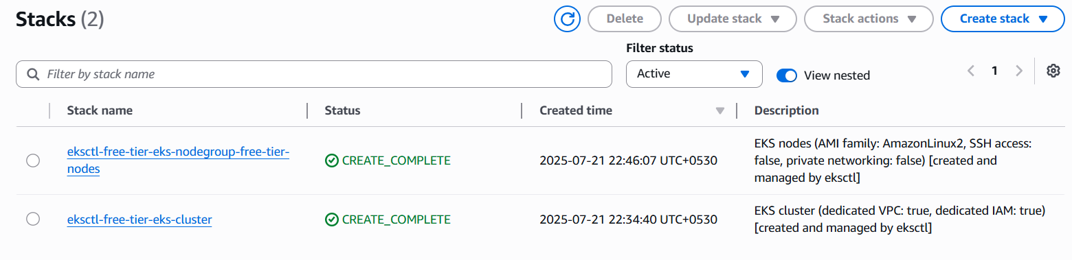
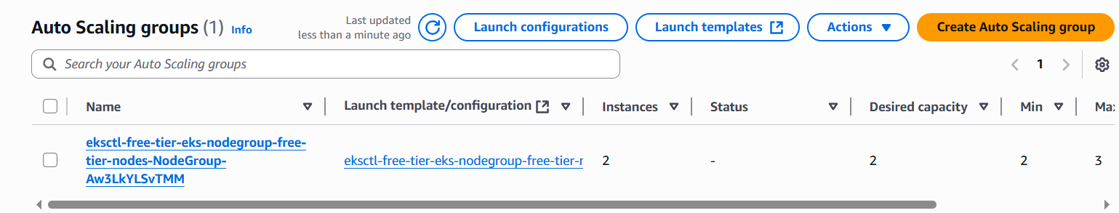
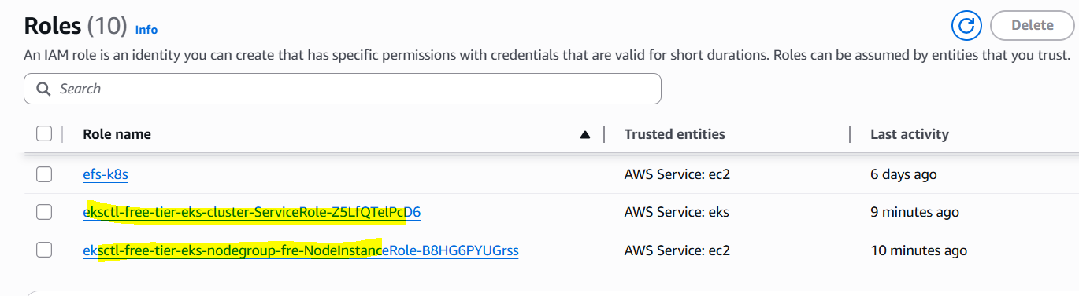
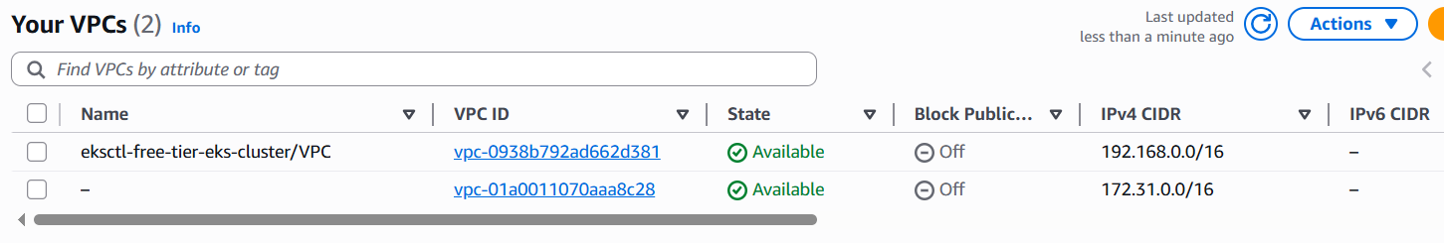

2) Setup EKS cluster using Console
This task involves manual steps in the AWS Management Console.

Steps
- Log in to AWS Management Console: Go to the AWS console and search for EKS.
- Create Cluster: Click "Create cluster" and provide a cluster name, Kubernetes version, and select the EKS Cluster IAM role.
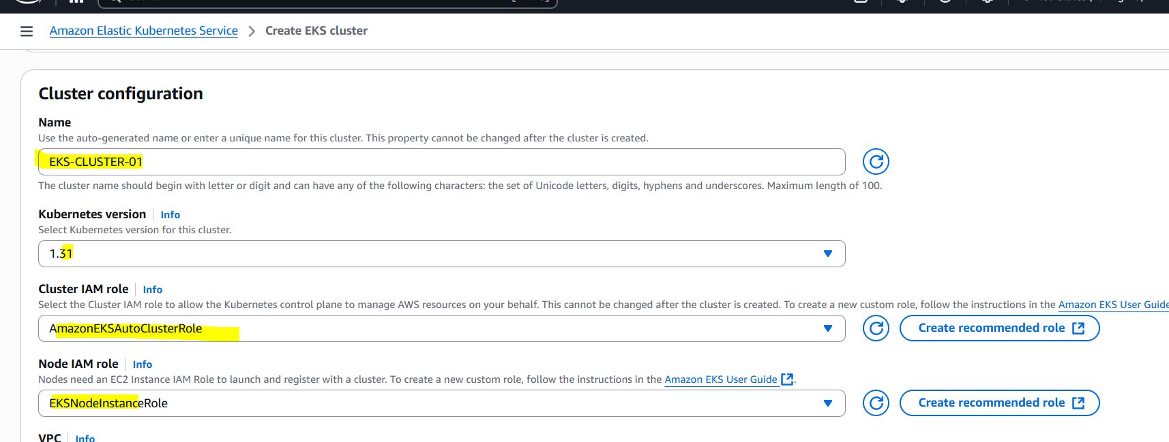
- Configure Networking: Choose your VPC and subnets. Ensure public access is enabled if you want to access the cluster from outside the VPC.
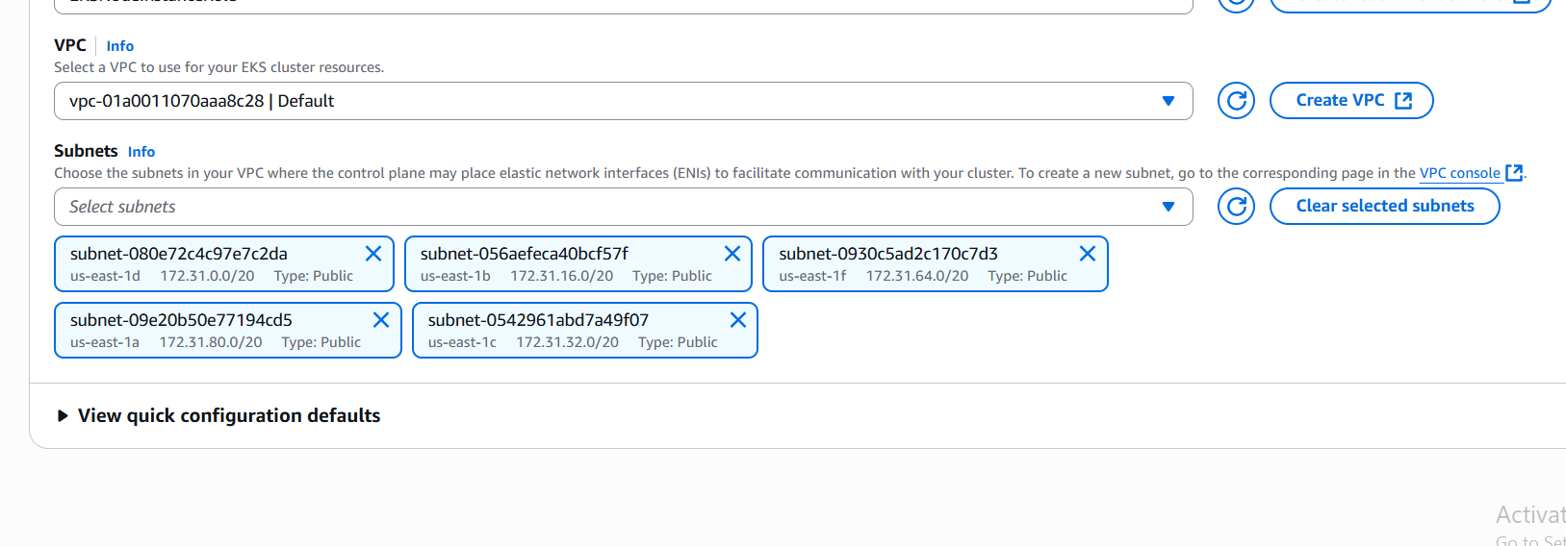
- Create Node Group: Navigate to the "Compute" tab of your cluster and click "Add node group".
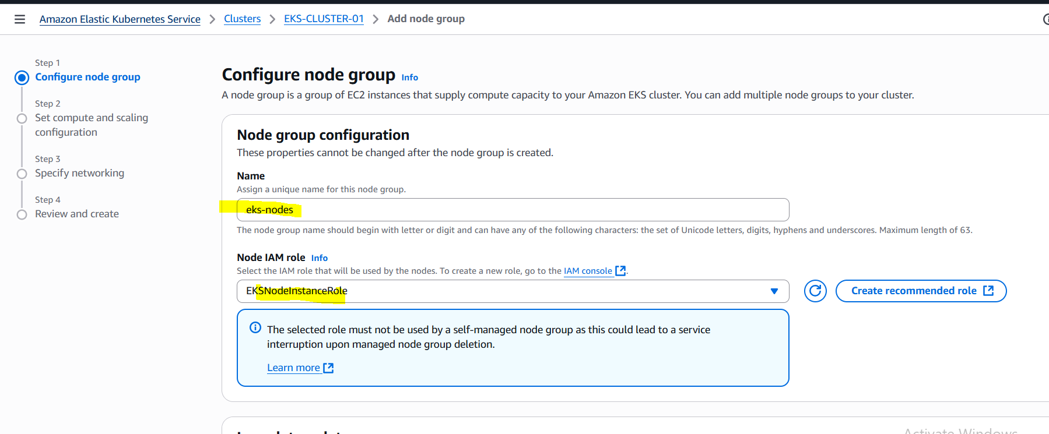
- Node Group Configuration: Provide a node group name, select the EC2 instance type (e.g., t3.small), specify min/max/desired sizes, and choose the EKS Node IAM role.
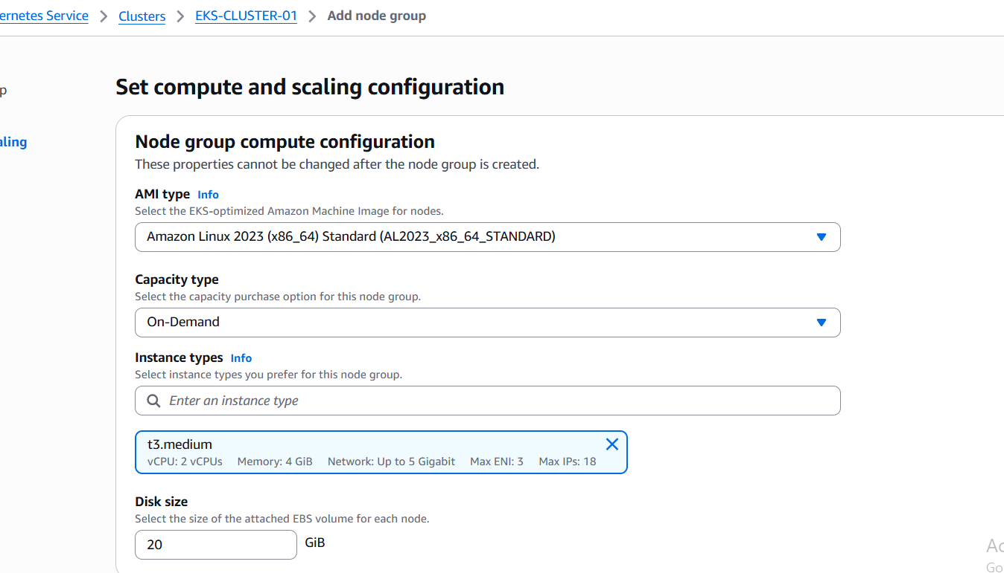
- Networking for Node Group: Select subnets for your nodes.
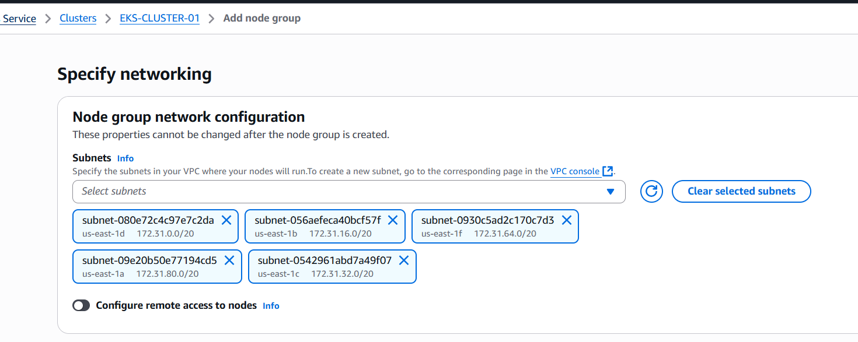
- Review and Create: Review your configuration and create the cluster and node group.
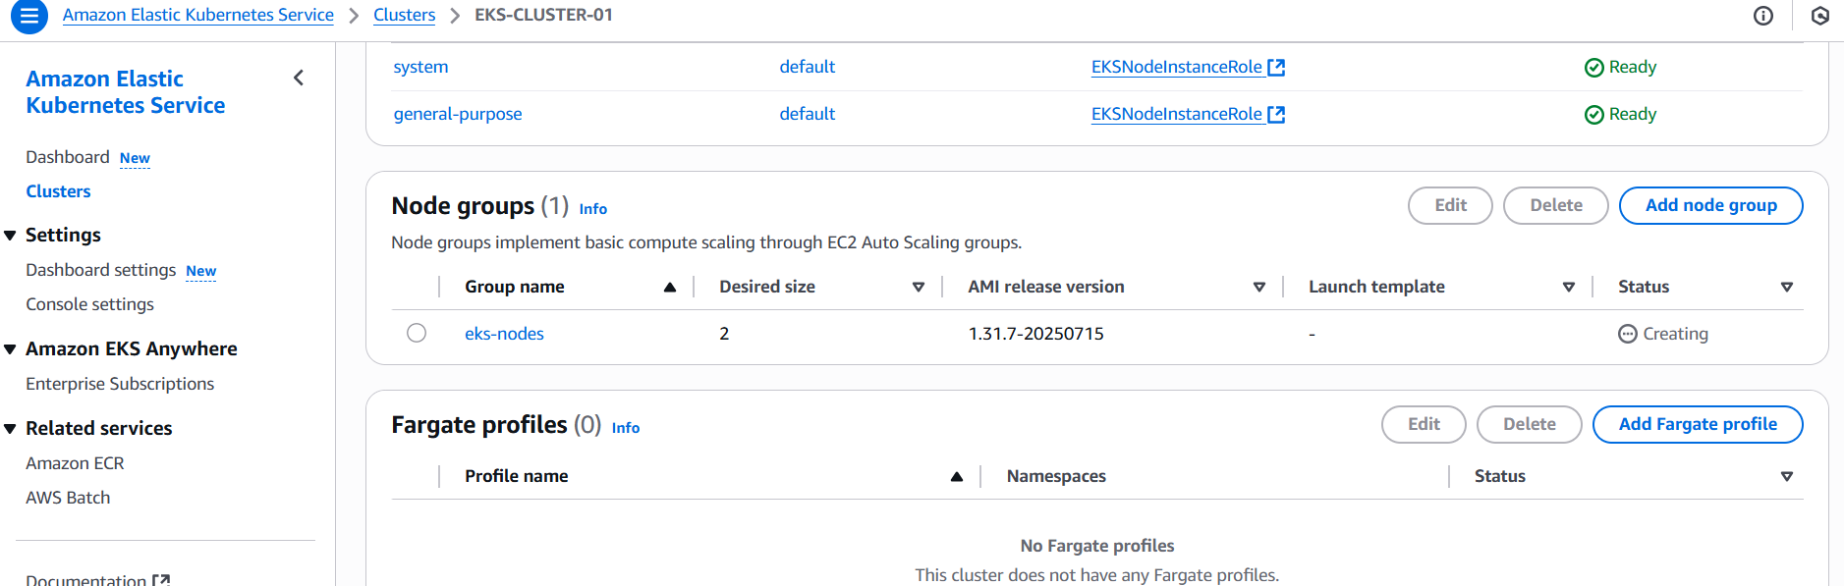
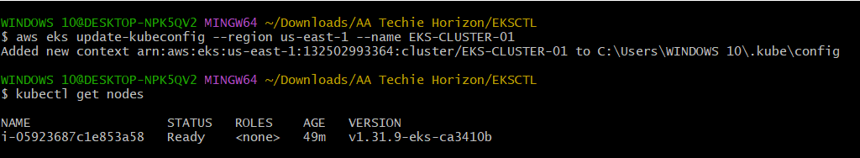

3) Setup HPA (Horizontal Pod Autoscaler)

YAMLs
nginx-deployment.yaml
---
apiVersion: apps/v1
kind: Deployment
metadata:
name: nginx-deployment
spec:
replicas: 1
selector:
matchLabels:
app: nginx
template:
metadata:
labels:
app: nginx
spec:
containers:
- name: nginx
image: nginx
resources:
requests:
cpu: 100m
limits:
cpu: 200m
ports:
- containerPort: 80

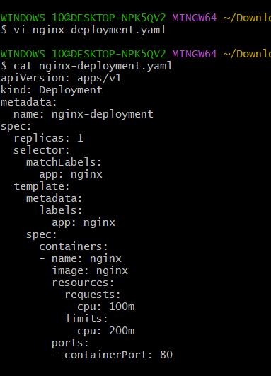

hpa.yaml
---
apiVersion: autoscaling/v2
kind: HorizontalPodAutoscaler
metadata:
name: nginx-hpa
spec:
scaleTargetRef:
apiVersion: apps/v1
kind: Deployment
name: nginx-deployment
minReplicas: 1
maxReplicas: 5
metrics:
- type: Resource
resource:
name: cpu
target:
type: Utilization
averageUtilization: 20

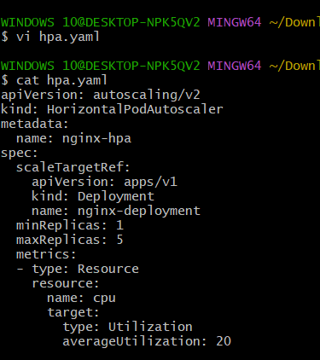

nginx-nodeport-service.yaml
---
apiVersion: v1
kind: Service
metadata:
name: nginx-service
spec:
type: NodePort
selector:
app: nginx
ports:
- port: 80
targetPort: 80
nodePort: 30080

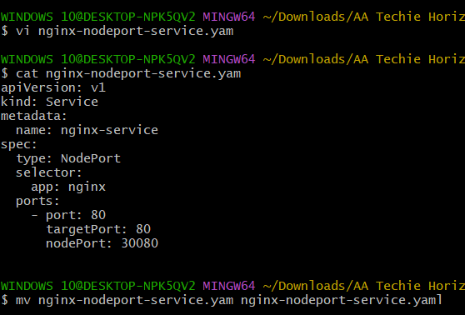

load-generator.yaml
---
apiVersion: v1
kind: Pod
metadata:
name: load-generator
spec:
containers:
- name: busybox
image: busybox
command: ["/bin/sh"]
args: ["-c", "while true; do wget -q -O- http://nginx-service.default.svc.cluster.local; done"]

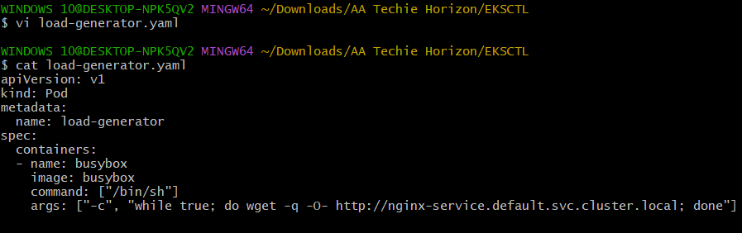

Commands
kubectl apply -f nginx-deployment.yaml # Deploy the Nginx application
kubectl apply -f nginx-nodeport-service.yaml # Create a NodePort service for Nginx
kubectl apply -f hpa.yaml # Apply the Horizontal Pod Autoscaler configuration
kubectl top nodes # Check CPU utilization for nodes (requires Metrics Server)
kubectl top pods # Check CPU utilization for pods (requires Metrics Server)

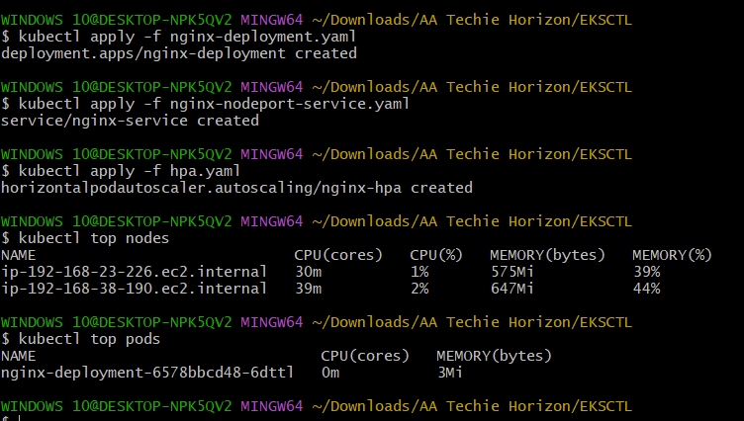

kubectl get hpa # Get the status of the HPA
kubectl apply -f load-generator.yaml # Deploy a pod to generate load
sleep 120 # Wait for HPA to scale up (adjust as needed)
kubectl get pods -l app=nginx # Check the scaled pods
kubectl delete -f load-generator.yaml # Delete the load generator to reduce load

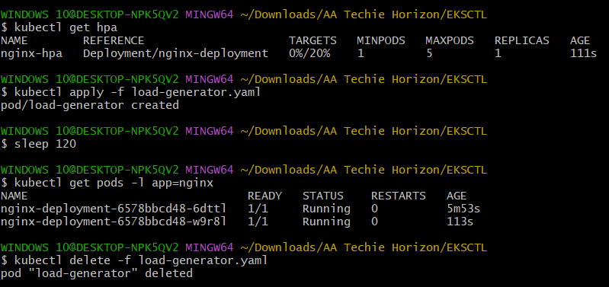

4) Setup Cluster Autoscaler

Commands
aws autoscaling describe-auto-scaling-groups --query "AutoScalingGroups[*].AutoScalingGroupName" --output table # Get the name of your Auto Scaling Group (replace <ASG_NAME> below)
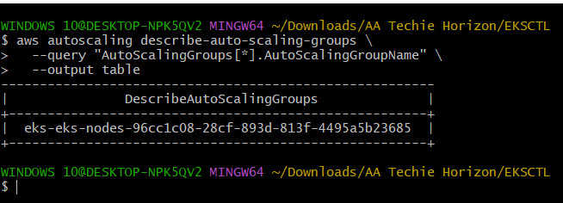

aws autoscaling create-or-update-tags --tags ResourceId=<ASG_NAME>,ResourceType=auto-scaling-group,Key=k8s.io/cluster-autoscaler/enabled,Value=true,PropagateAtLaunch=true ResourceId=<ASG_NAME>,ResourceType=auto-scaling-group,Key=k8s.io/cluster-autoscaler/free-tier-eks,Value=owned,PropagateAtLaunch=true # Tag the ASG for Cluster Autoscaler (replace <ASG_NAME> and 'free-tier-eks' with your cluster name)

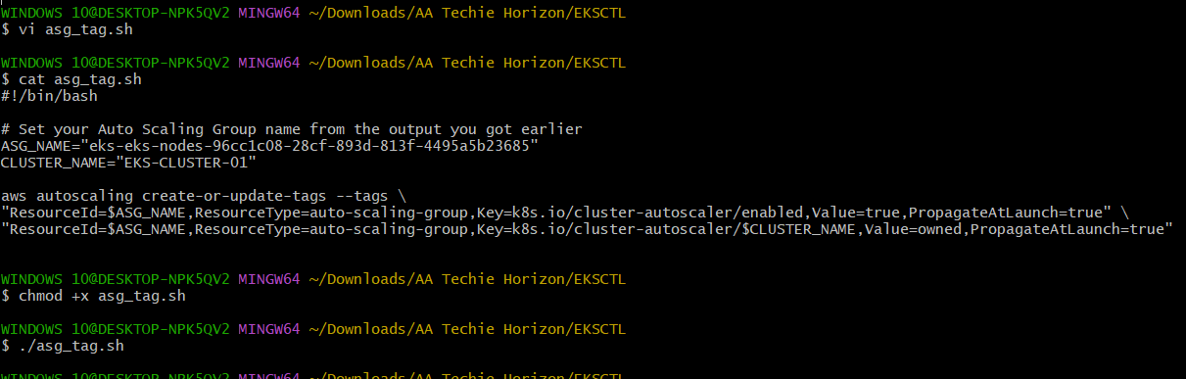
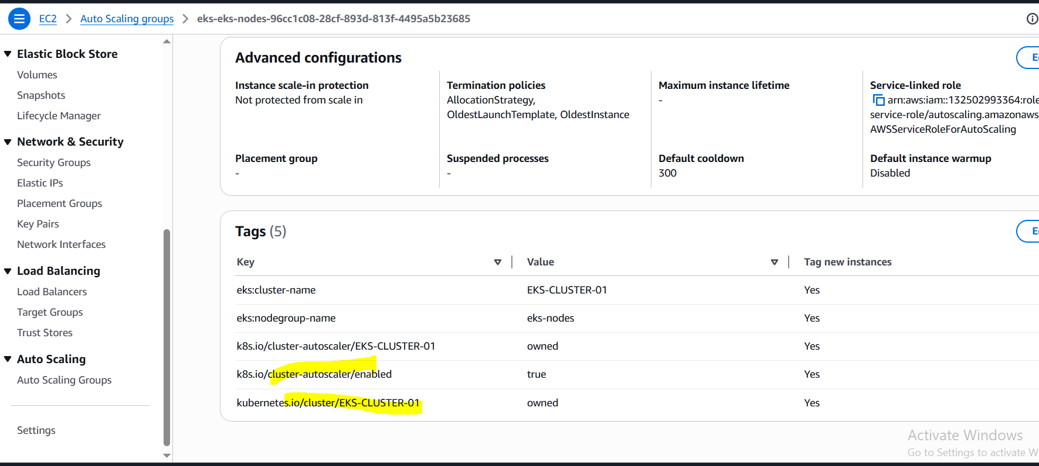

# Create IAM policy for Cluster Autoscaler (policy name: AmazonEKSClusterAutoscalerPolicy, follow the JSON provided in the problem statement)

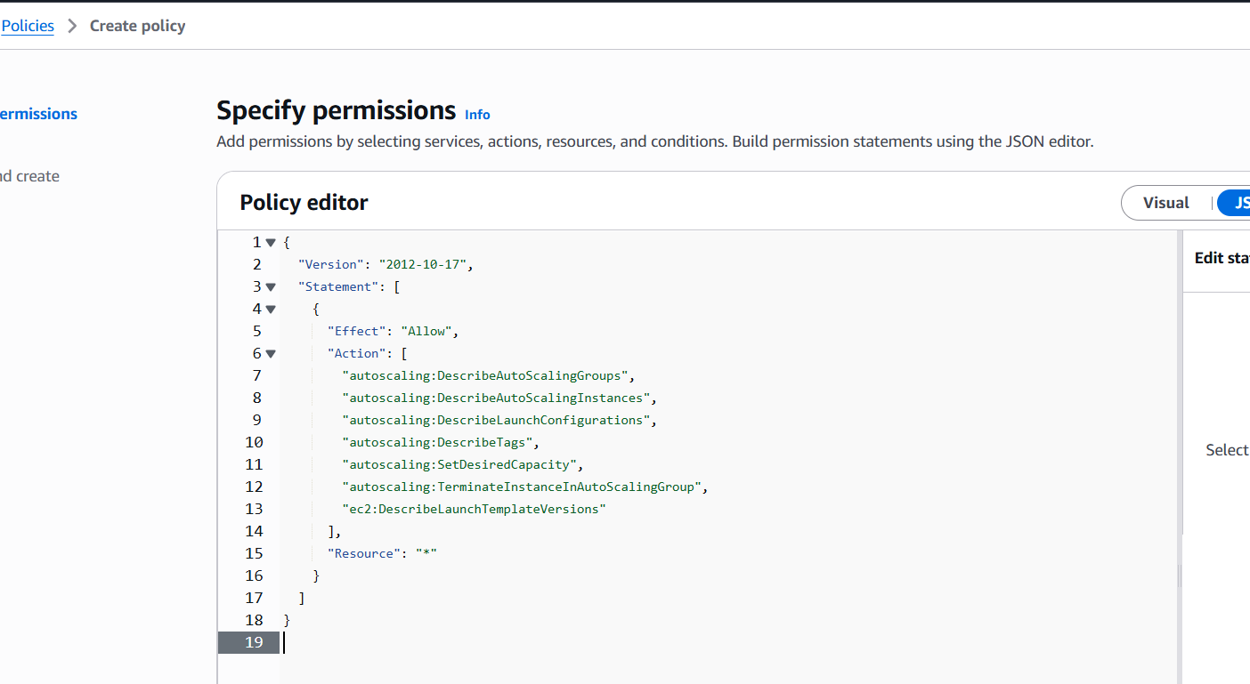
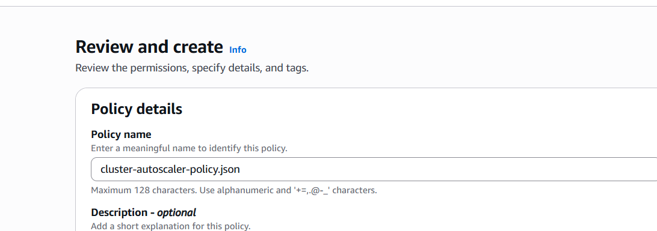

eksctl create iamserviceaccount --cluster free-tier-eks --namespace kube-system --name cluster-autoscaler --attach-policy-arn arn:aws:iam::<AWS_ACCOUNT_ID>:policy/AmazonEKSClusterAutoscalerPolicy --approve # Create IAM service account for Cluster Autoscaler (replace <AWS_ACCOUNT_ID> and 'free-tier-eks')

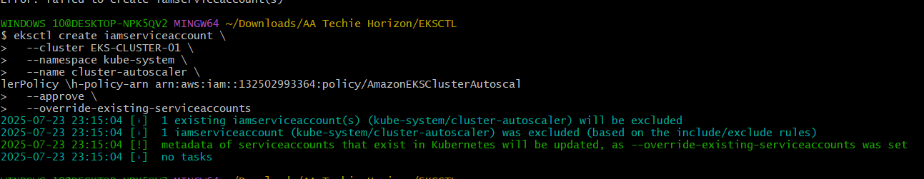

kubectl apply -f https://raw.githubusercontent.com/kubernetes/autoscaler/cluster-autoscaler-1.29.0/cluster-autoscaler/cloudprovider/aws/examples/cluster-autoscaler-autodiscover.yaml # Install Cluster Autoscaler

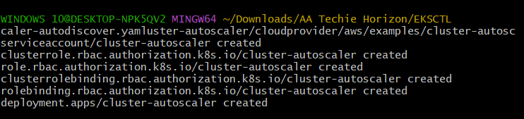

kubectl -n kube-system edit deployment.apps/cluster-autoscaler # Edit the Cluster Autoscaler deployment to add your cluster name in args

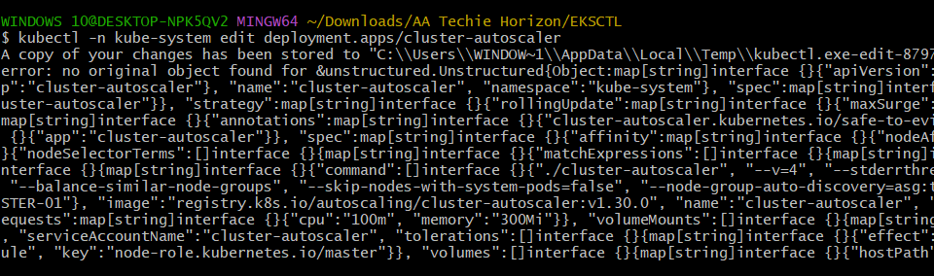

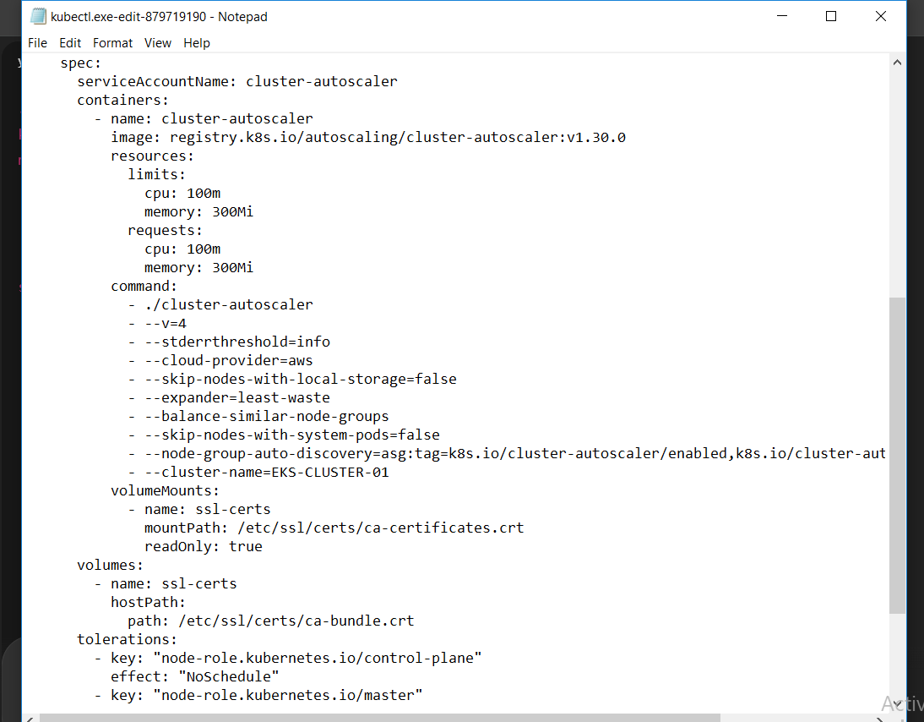

kubectl -n kube-system logs deployment/cluster-autoscaler # Verify Cluster Autoscaler logs

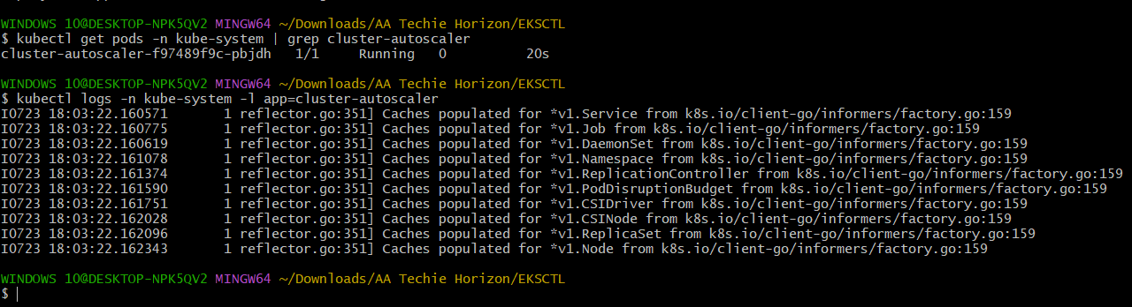

YAMLs (for testing Cluster Autoscaler)
test-deployment.yaml
---
apiVersion: apps/v1
kind: Deployment
metadata:
name: test-deployment
spec:
replicas: 5
selector:
matchLabels:
app: test
template:
metadata:
labels:
app: test
spec:
containers:
- name: test-container
image: nginx
resources:
requests:
cpu: "500m"
memory: "512Mi"
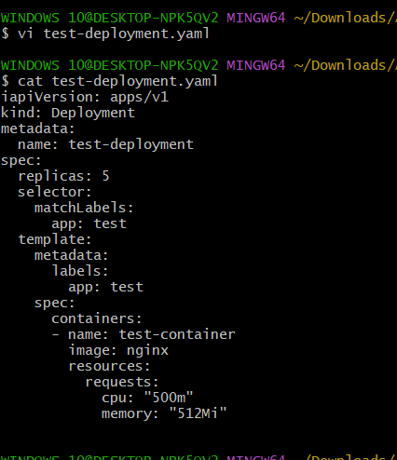

Commands (for testing Cluster Autoscaler)
kubectl apply -f test-deployment.yaml # Deploy a high resource demand application to test autoscaling
sleep 180 # Wait for Cluster Autoscaler to provision new nodes

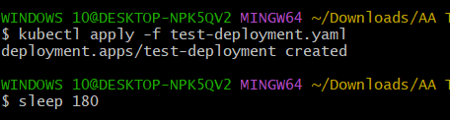

kubectl get nodes # Check for newly provisioned nodes

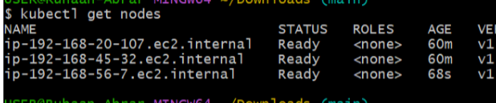

5) Setup CronJob and Job

YAMLs
cronjob.yaml
---
apiVersion: batch/v1
kind: CronJob
metadata:
name: test-cronjob
namespace: default
spec:
schedule: "*/1 * * * *"
successfulJobsHistoryLimit: 3
failedJobsHistoryLimit: 1
jobTemplate:
spec:
template:
spec:
restartPolicy: OnFailure
containers:
- name: date-printer
image: busybox:1.35
args:
- /bin/sh
- -c
- date; echo "Hello from EKS CronJob"
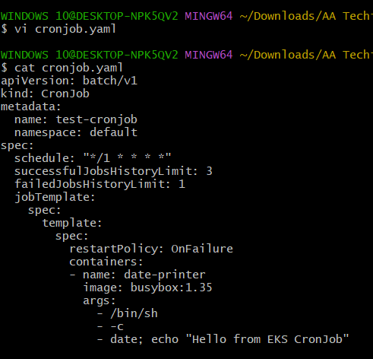

Commands
kubectl apply -f cronjob.yaml # Apply the cronjob configuration
kubectl get cronjob # Check the cronjob status
sleep 60 # Wait for a minute for the job to run

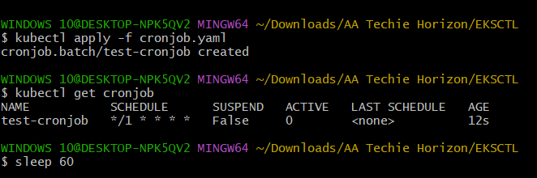

kubectl get pods -l job-name # Get the pods created by the cronjob
kubectl logs <pod-name-from-get-pods> # Check the logs of the job pod (replace <pod-name-from-get-pods>)

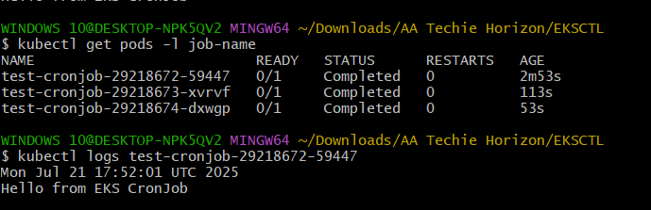
For a one-time Job, you can use a similar YAML structure as jobTemplate within the CronJob, but directly as a Job kind.
one-time-job.yaml
---
apiVersion: batch/v1
kind: Job
metadata:
name: my-one-time-job
spec:
template:
spec:
containers:
- name: job-container
image: busybox:1.35
command: ["echo", "Hello from a one-time job!"]
restartPolicy: Never
backoffLimit: 4

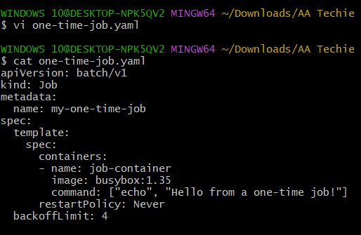

Commands (for one-time Job)
kubectl apply -f one-time-job.yaml # Apply the one-time job configuration
kubectl get jobs # Check the job status
kubectl get pods -l job-name=my-one-time-job # Get the pod created by the job
kubectl logs <pod-name-from-get-pods> # Check the logs of the job pod (replace <pod-name-from-get-pods>)

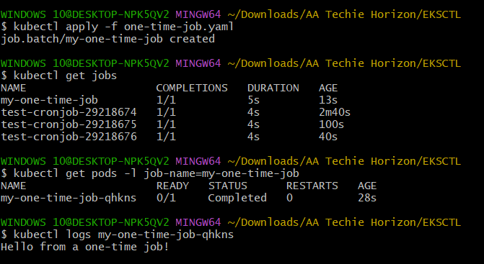

6) Create Secret and Inject Inside Pod

YAMLs
serviceaccount.yaml
---
apiVersion: v1
kind: ServiceAccount
metadata:
name: secrets-sa
namespace: default
annotations:
eks.amazonaws.com/role-arn: arn:aws:iam::915992498174:role/SecretsManagerAccessRole # Replace with your AWS account ID and role name

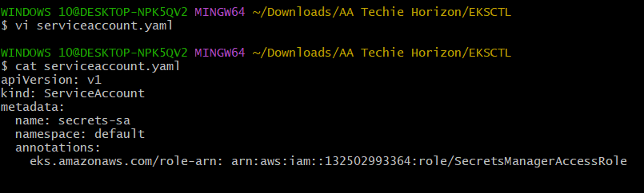

deployment.yaml
---
apiVersion: apps/v1
kind: Deployment
metadata:
name: secret-app
spec:
replicas: 1
selector:
matchLabels:
app: secret-app
template:
metadata:
labels:
app: secret-app
spec:
serviceAccountName: secrets-sa
containers:
- name: app
image: amazonlinux
command: [ "/bin/sh", "-c" ]
args:
- "yum install -y aws-cli jq; aws secretsmanager get-secret-value --secret-id db-credentials --region us-east-1 | jq .SecretString"

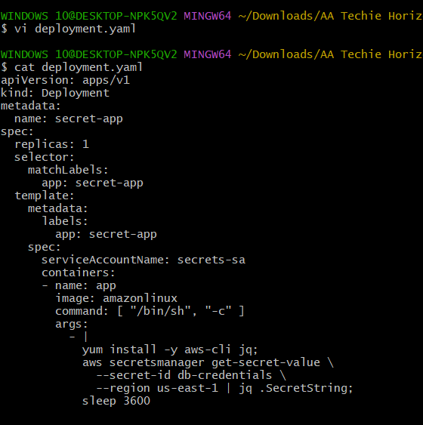

Commands
# Manually create a secret in AWS Secrets Manager named 'db-credentials' with some key-value pairs

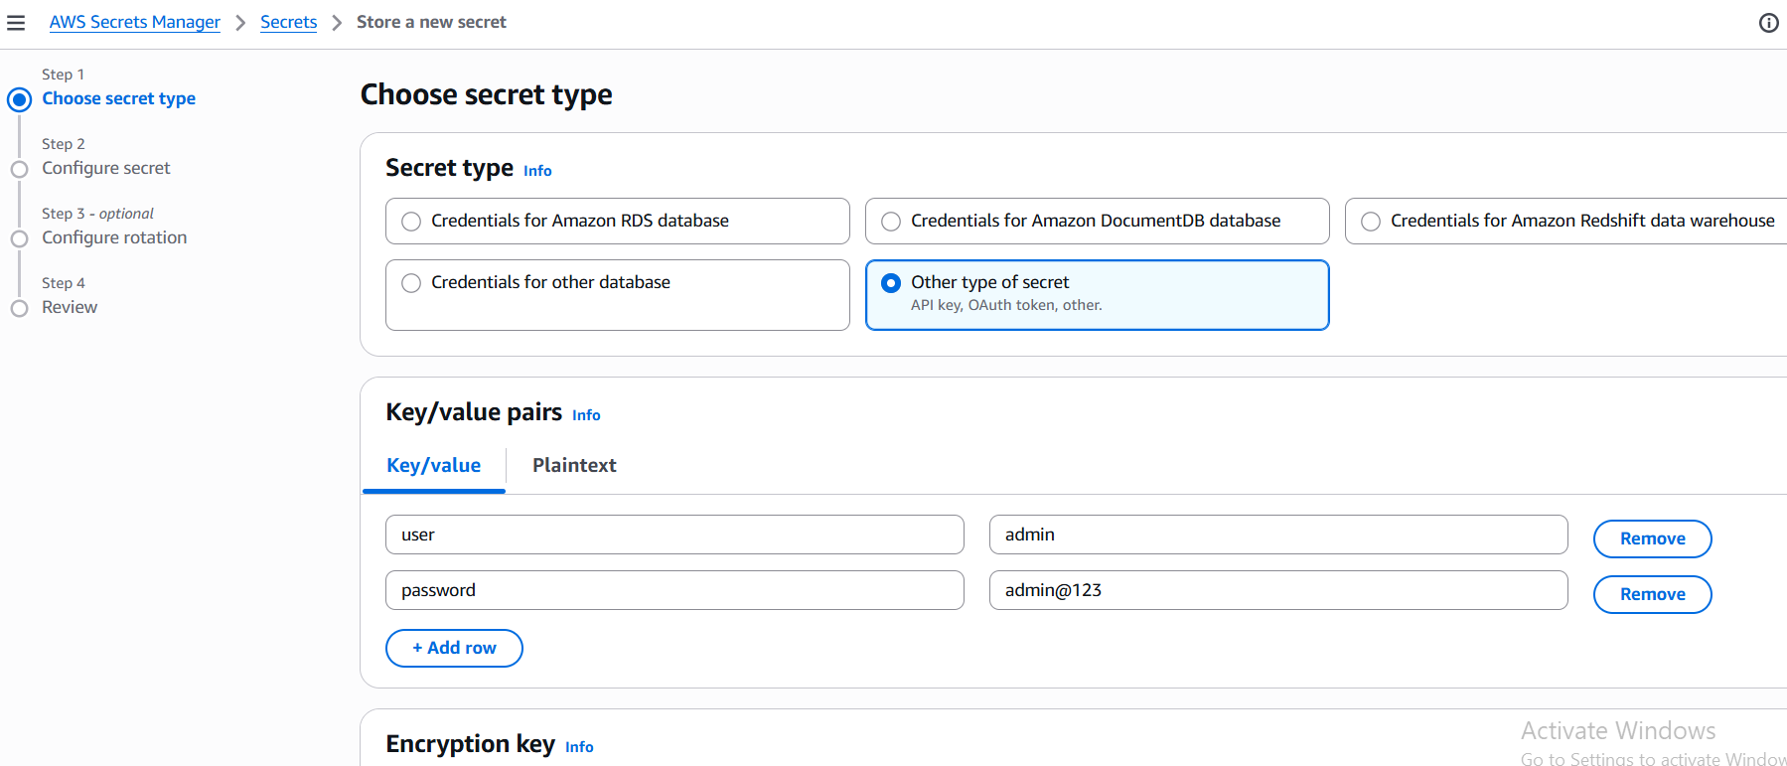
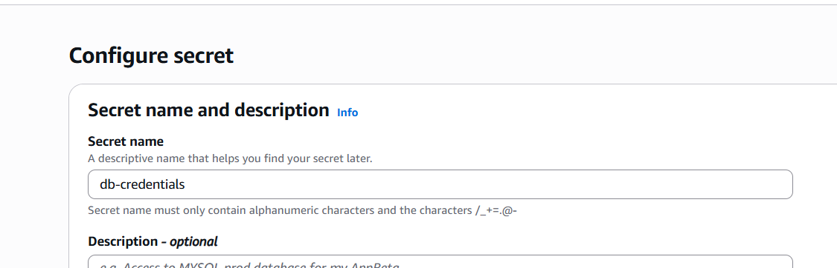
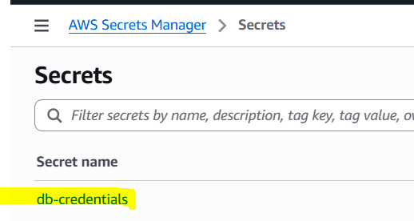

eksctl utils associate-iam-oidc-provider --region us-east-1 --cluster free-tier-eks --approve # Enable OIDC Provider for EKS (replace 'us-east-1' and 'free-tier-eks')

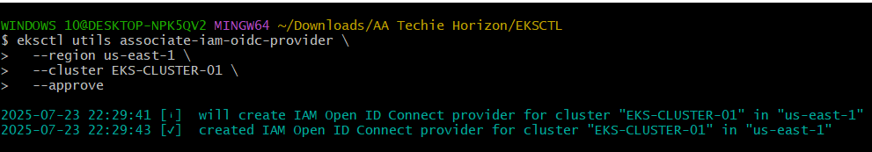

# Manually create IAM policy 'SecretsManagerAccessPolicy' with the provided JSON in AWS IAM (replace account ID and region in the Resource ARN)

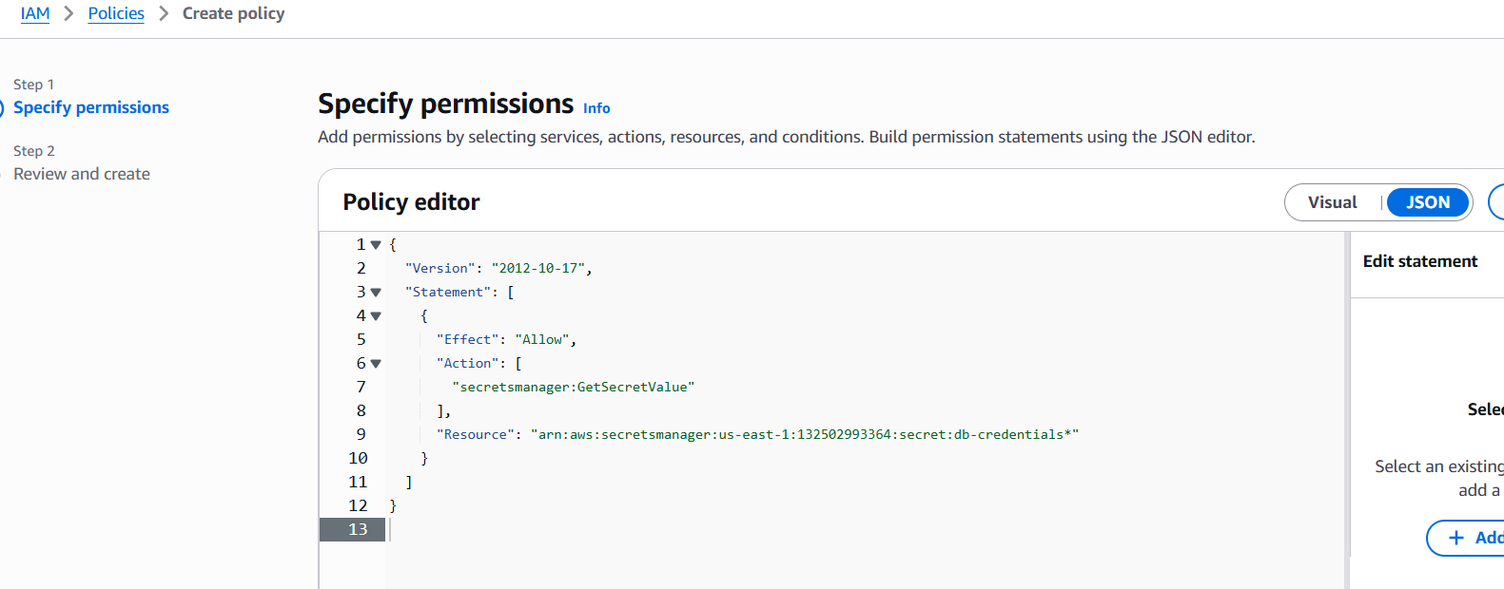
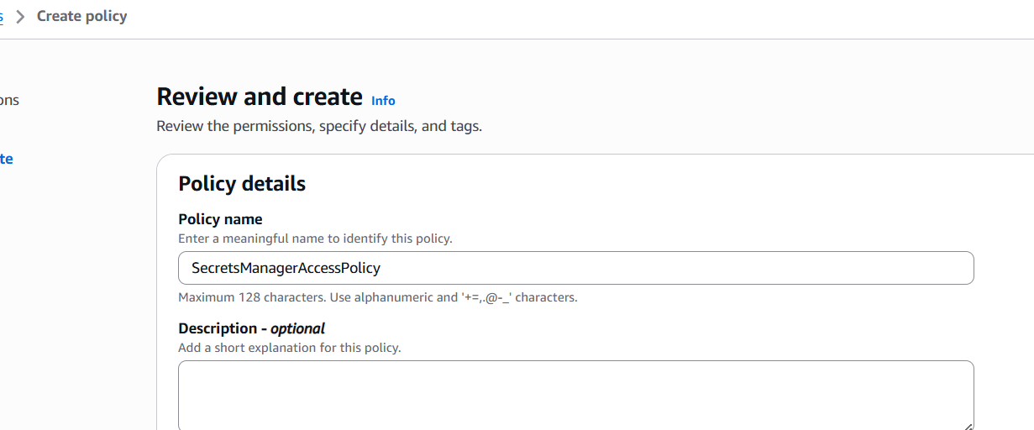

# Manually create IAM role 'SecretsManagerAccessRole' with the provided trust policy in AWS IAM (replace account ID, region, and <oidc-id> with your actual OIDC ID; namespace and service account name should match 'default' and 'secrets-sa') and attach 'SecretsManagerAccessPolicy'

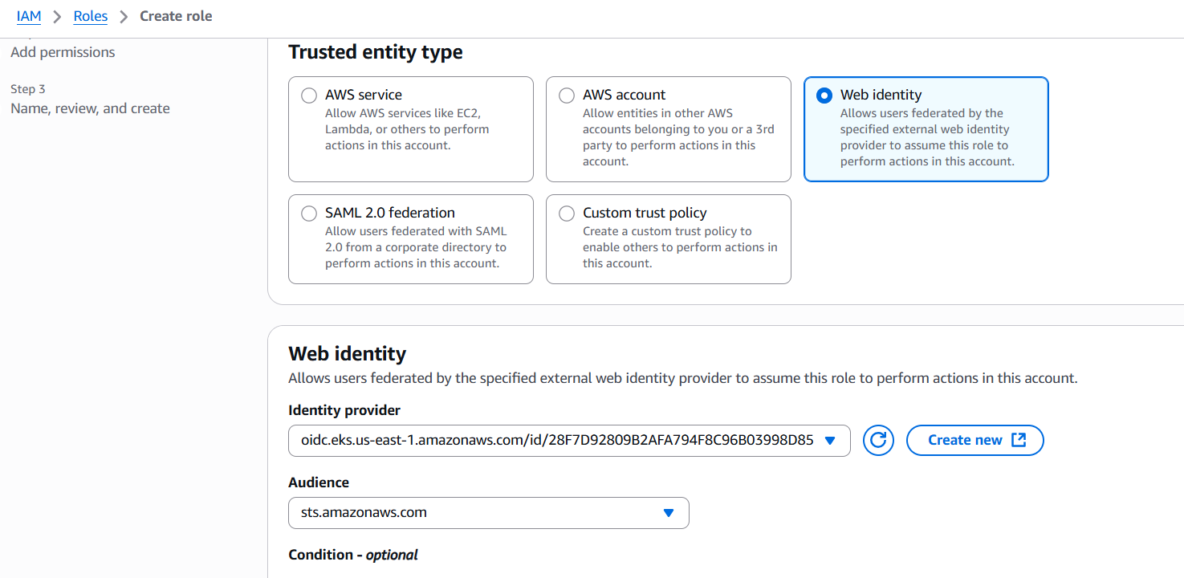
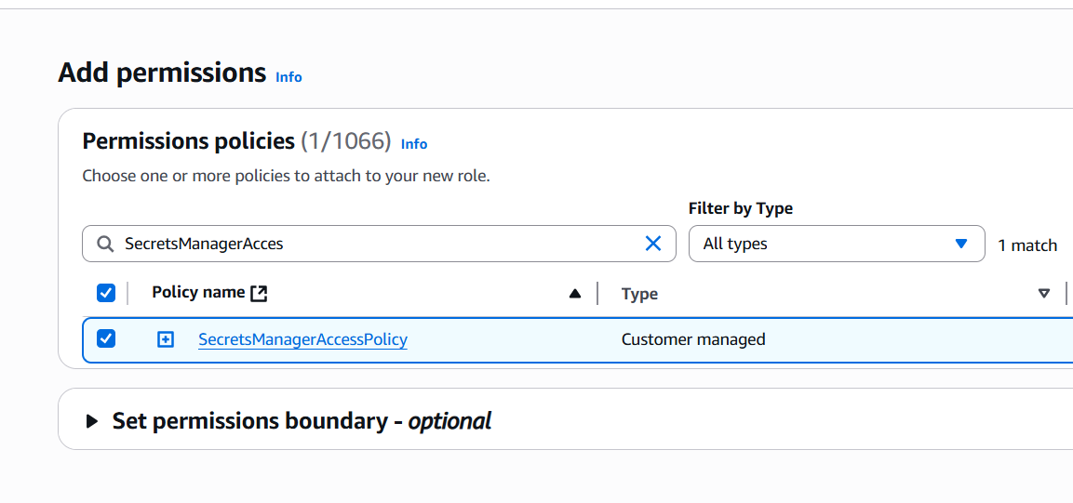
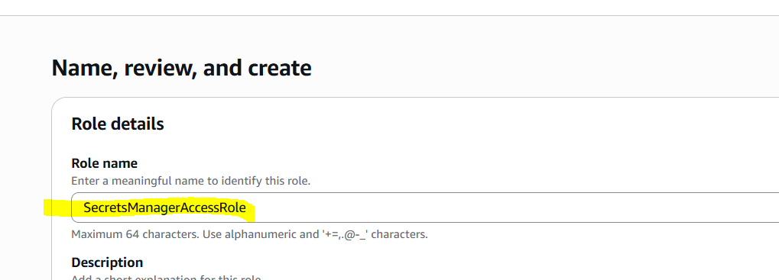

kubectl apply -f serviceaccount.yaml # Create the Kubernetes Service Account
kubectl apply -f deployment.yaml # Deploy the pod that uses the service account to access secrets

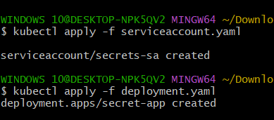

kubectl logs -l app=secret-app # Check logs to see the injected secret

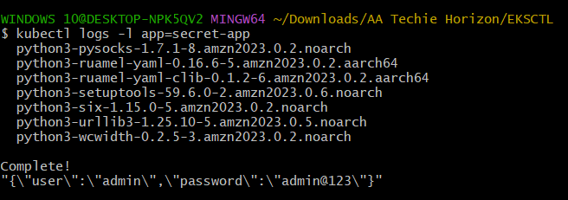

7) Check different Add-ons available on EKS

Commands
eksctl get addon --cluster free-tier-eks # List available add-ons for your EKS cluster (replace 'free-tier-eks')

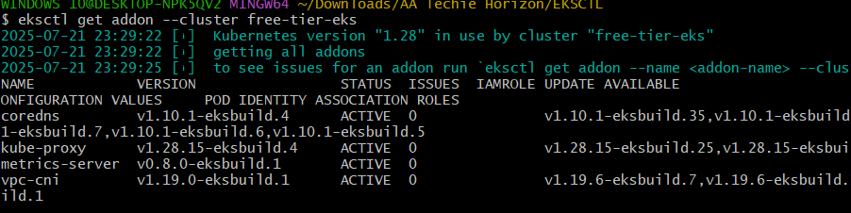
Note: You can also explore available add-ons and their versions via the AWS EKS console under your cluster's "Add-ons" tab.
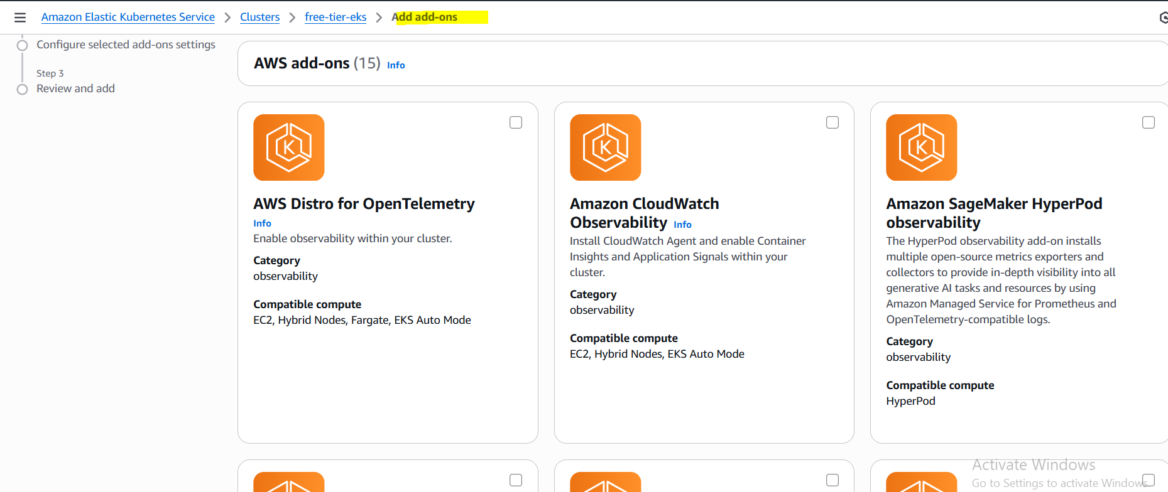

8) Upgrade EKS Cluster

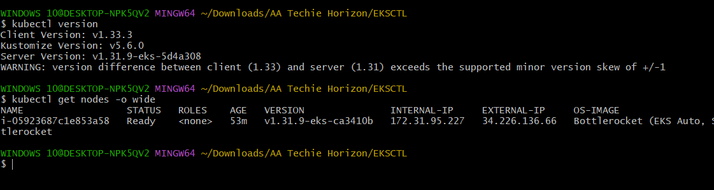
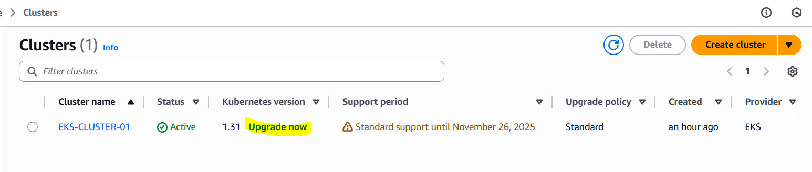
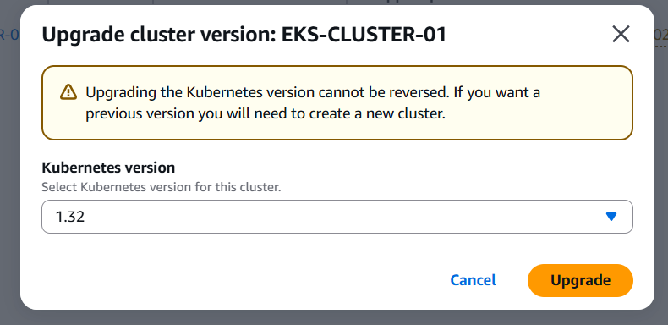

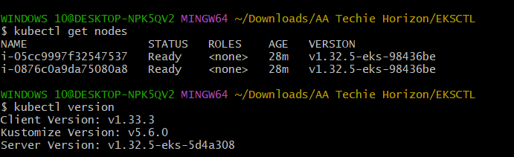

THE-END

